Lab 6: Learning Blob Storage Concept

Theory
Azure Blob Storage is a cloud-based object storage service provided by Microsoft Azure that is designed to store large amounts of unstructured data. Unstructured data includes text files, images, videos, audio files, backups, and static website content.
Blob Storage organizes data in the following hierarchy:
- Storage Account: the top-level container that provides a unique namespace.
- Container: a logical grouping of blobs (similar to a folder).
- Blob: the actual file stored (such as .html, .jpg, .pdf).
One important feature of Blob Storage is Static Website Hosting, which allows users to host static content such as HTML, CSS, and JavaScript files directly from a storage account without requiring a web server.

Steps:
- Create a storage account.
- Sign in to azure portal, click on Storage accounts and create one with necessary settings.
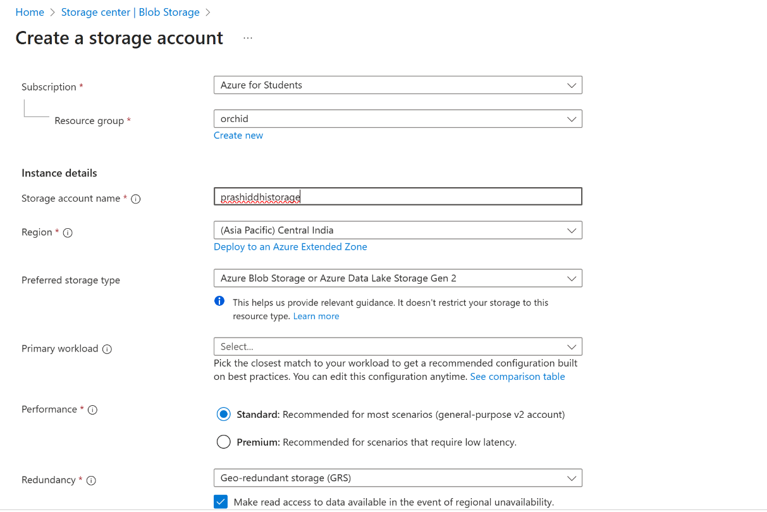

- In the advanced section, ensure that the Blob Storage access tier is set to Hot.

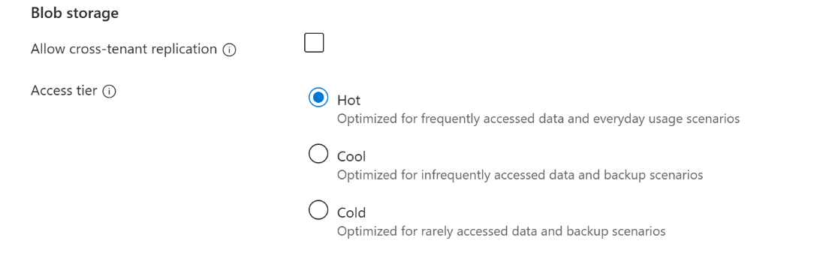

- Enable Blob Static Website
- Open the created Storage Account. Go to Data Management > Static Website. Then set Static website to enabled.

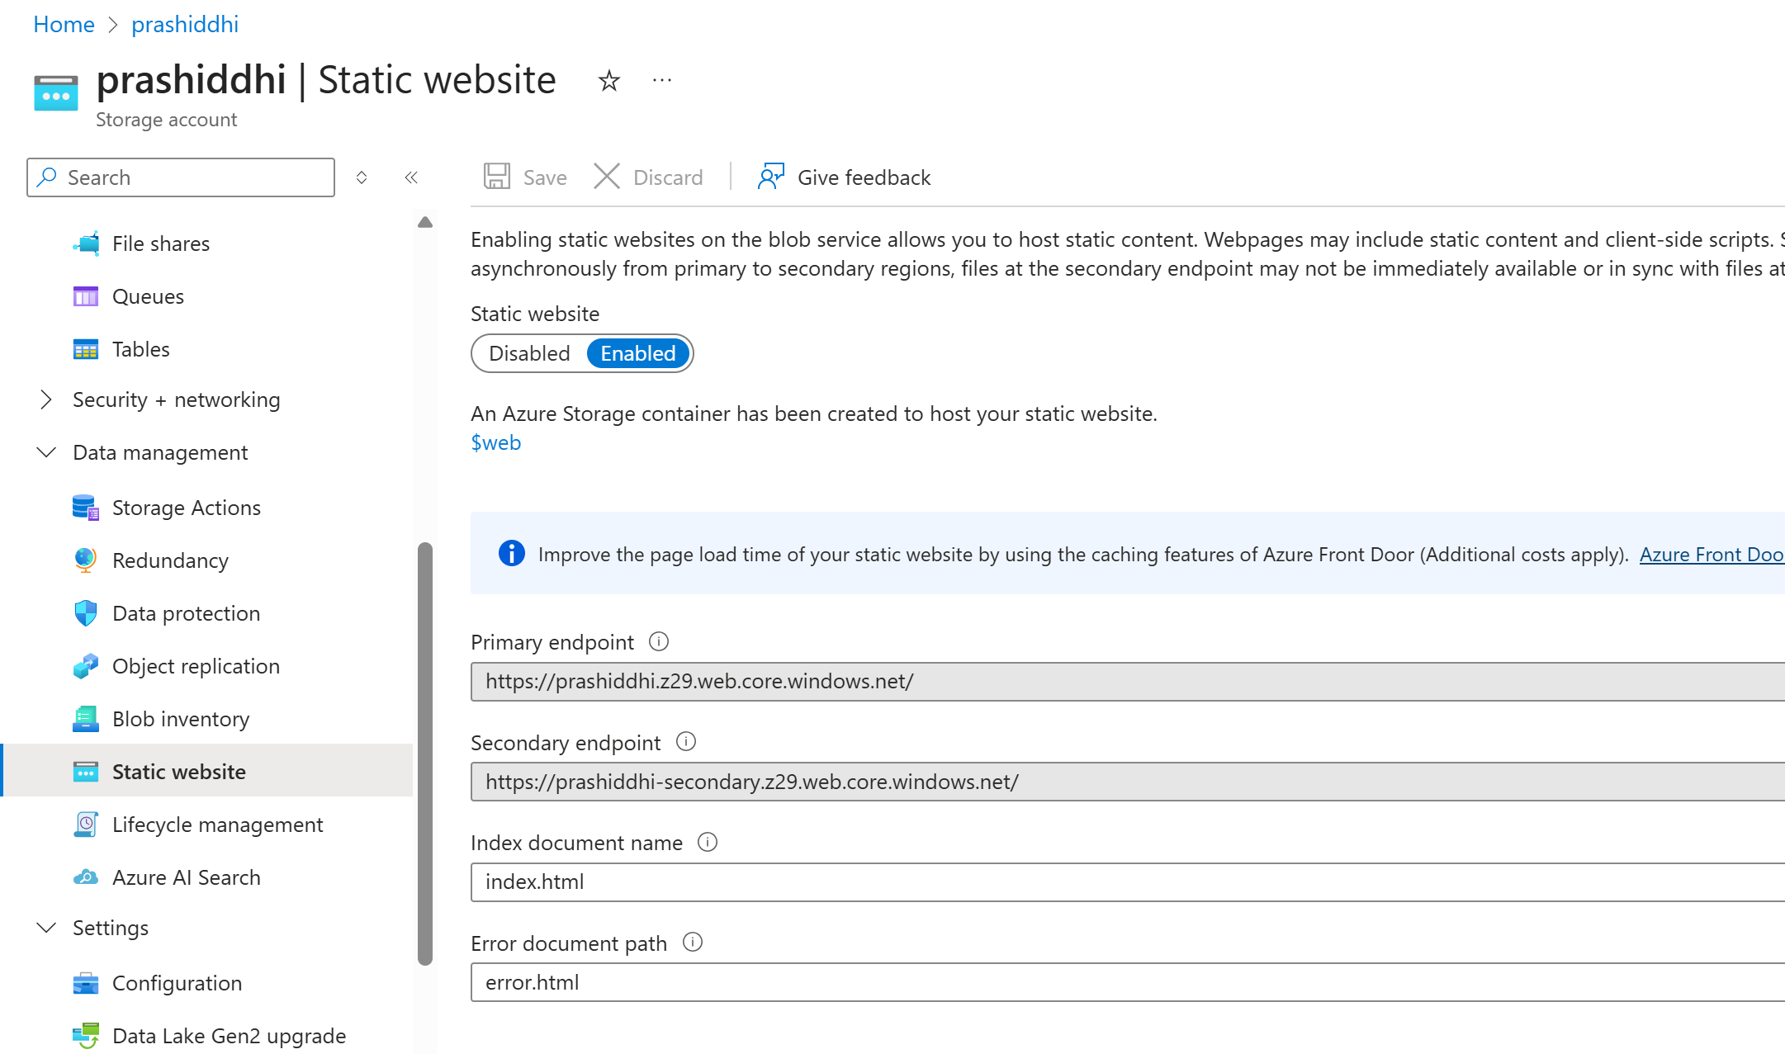

- Then, Enter:
- Index document name: index.html
- Error document path: error.html

- Navigate to Data Storage > Containers and observe that a special container named $web is automatically created.

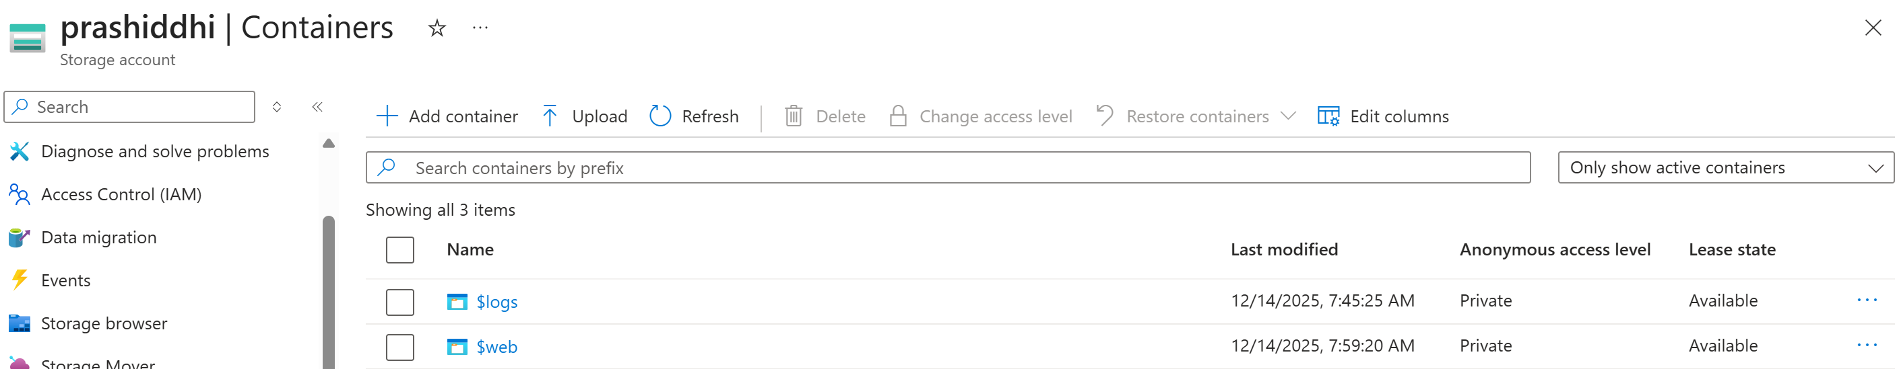
- In the $web container, upload files index.html and error.html from the local system.

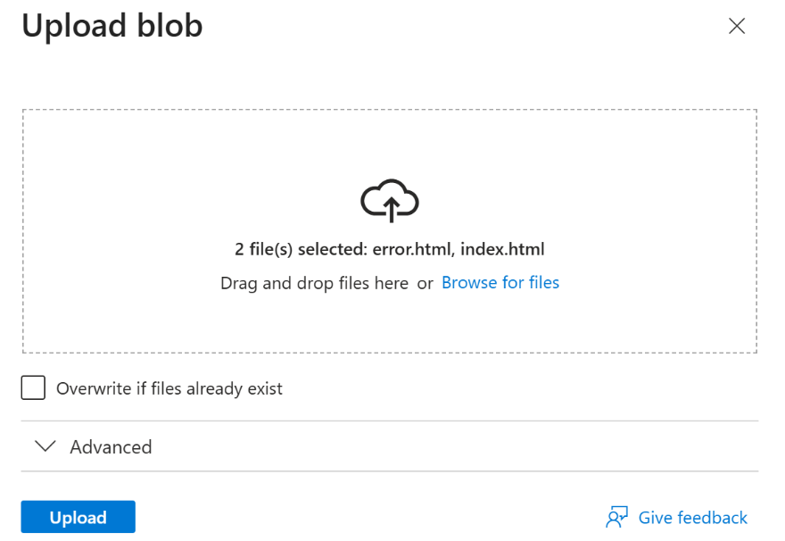
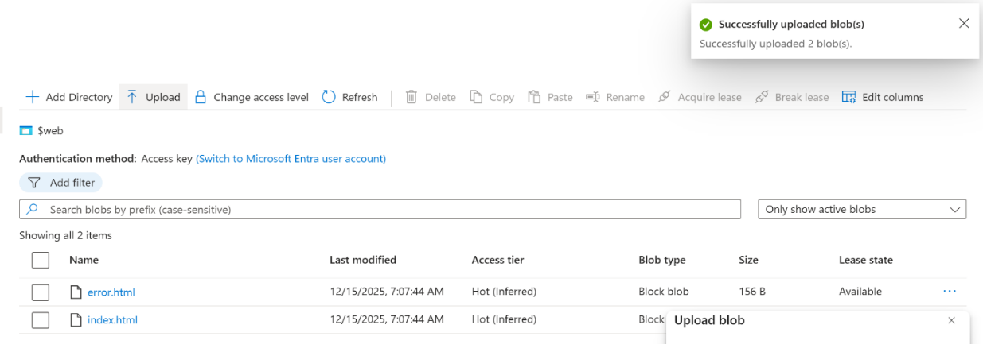

- Access the Website

- Copy the Primary endpoint URL from the Static website section. Open the URL in a web browser to view the website.

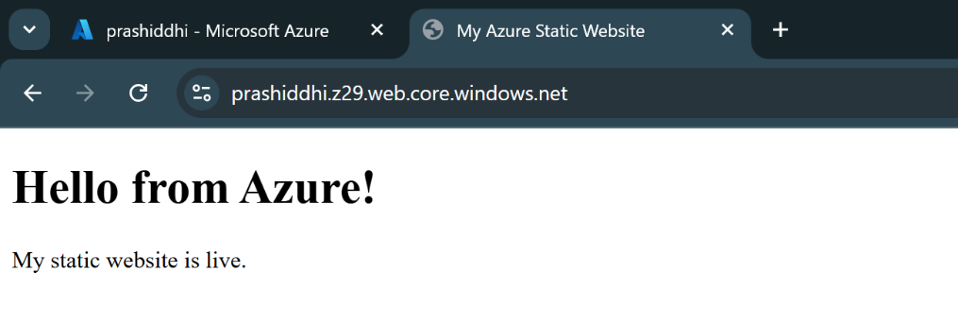

- Test the error page by entering an invalid URL path.
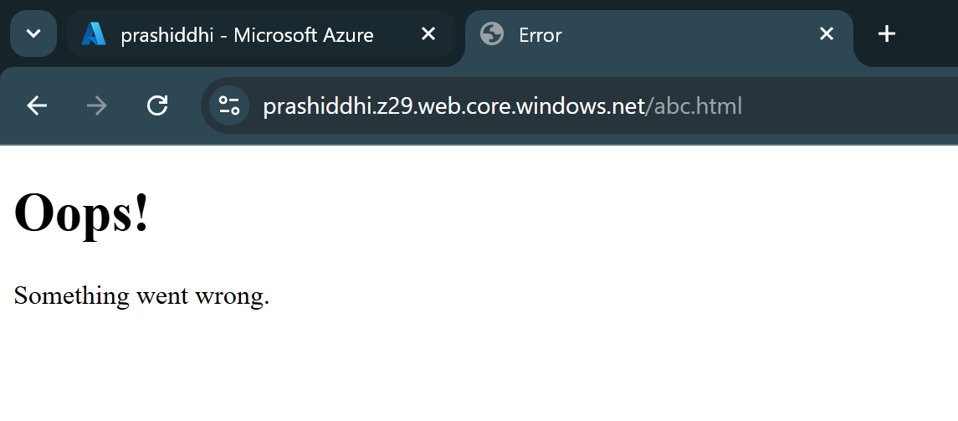
- Create a new Blob Container

- Navigate to Data Storage > Containers.

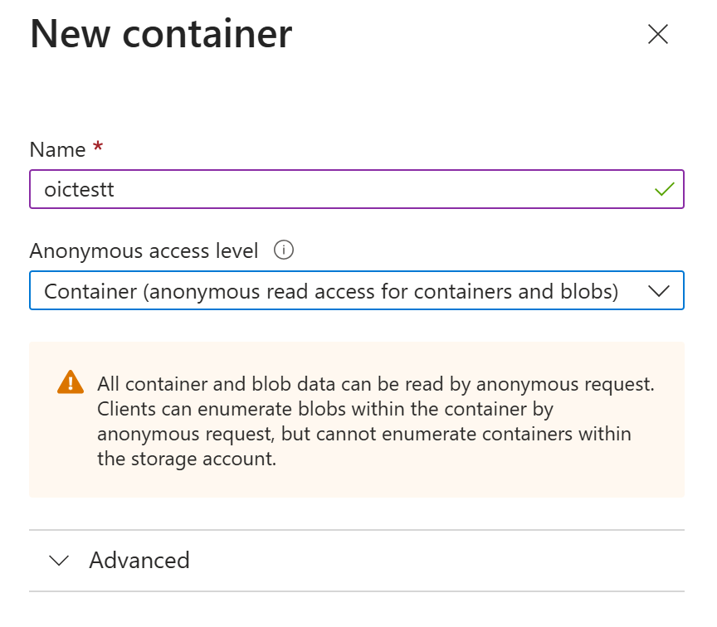

- Since, the access level is first set to private and cannot be updated make sure to enable Blob anonymous access in Settings > Configuration.


- Verify that the container has been created.

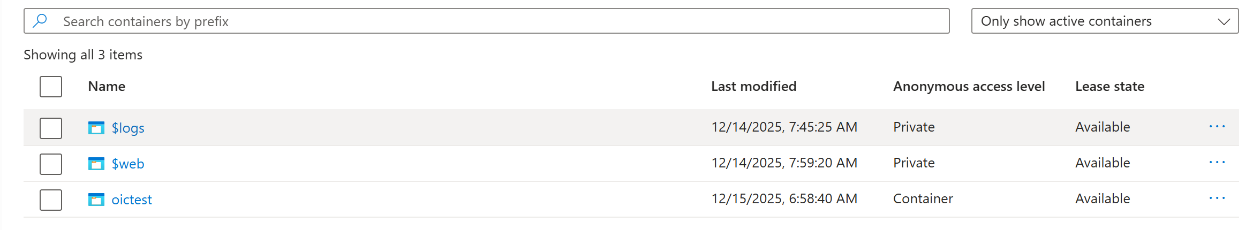

- Upload any PDF file in the newly made container.

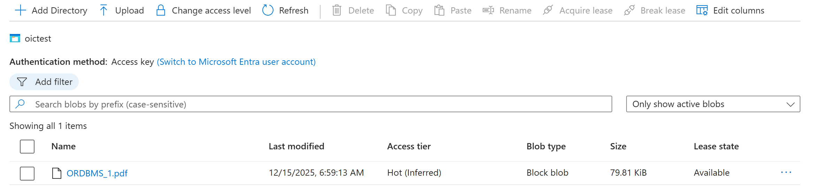

- Access the PDF using URL.

- Click on the uploaded PDF file and copy the Blob URL provided by Azure

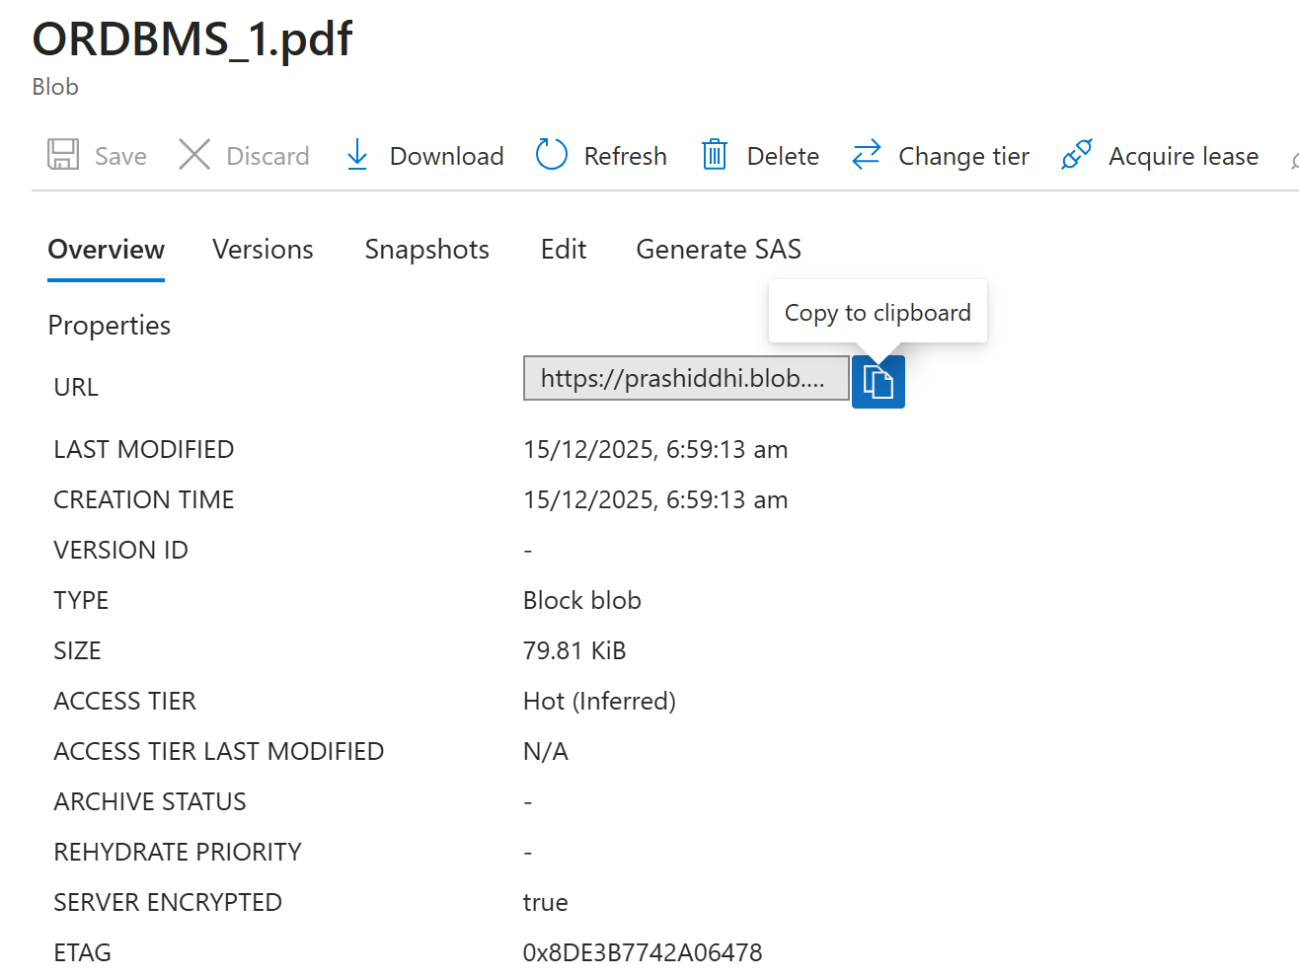

- Paste the URL in any browser and verify that it opens directly in the browser.

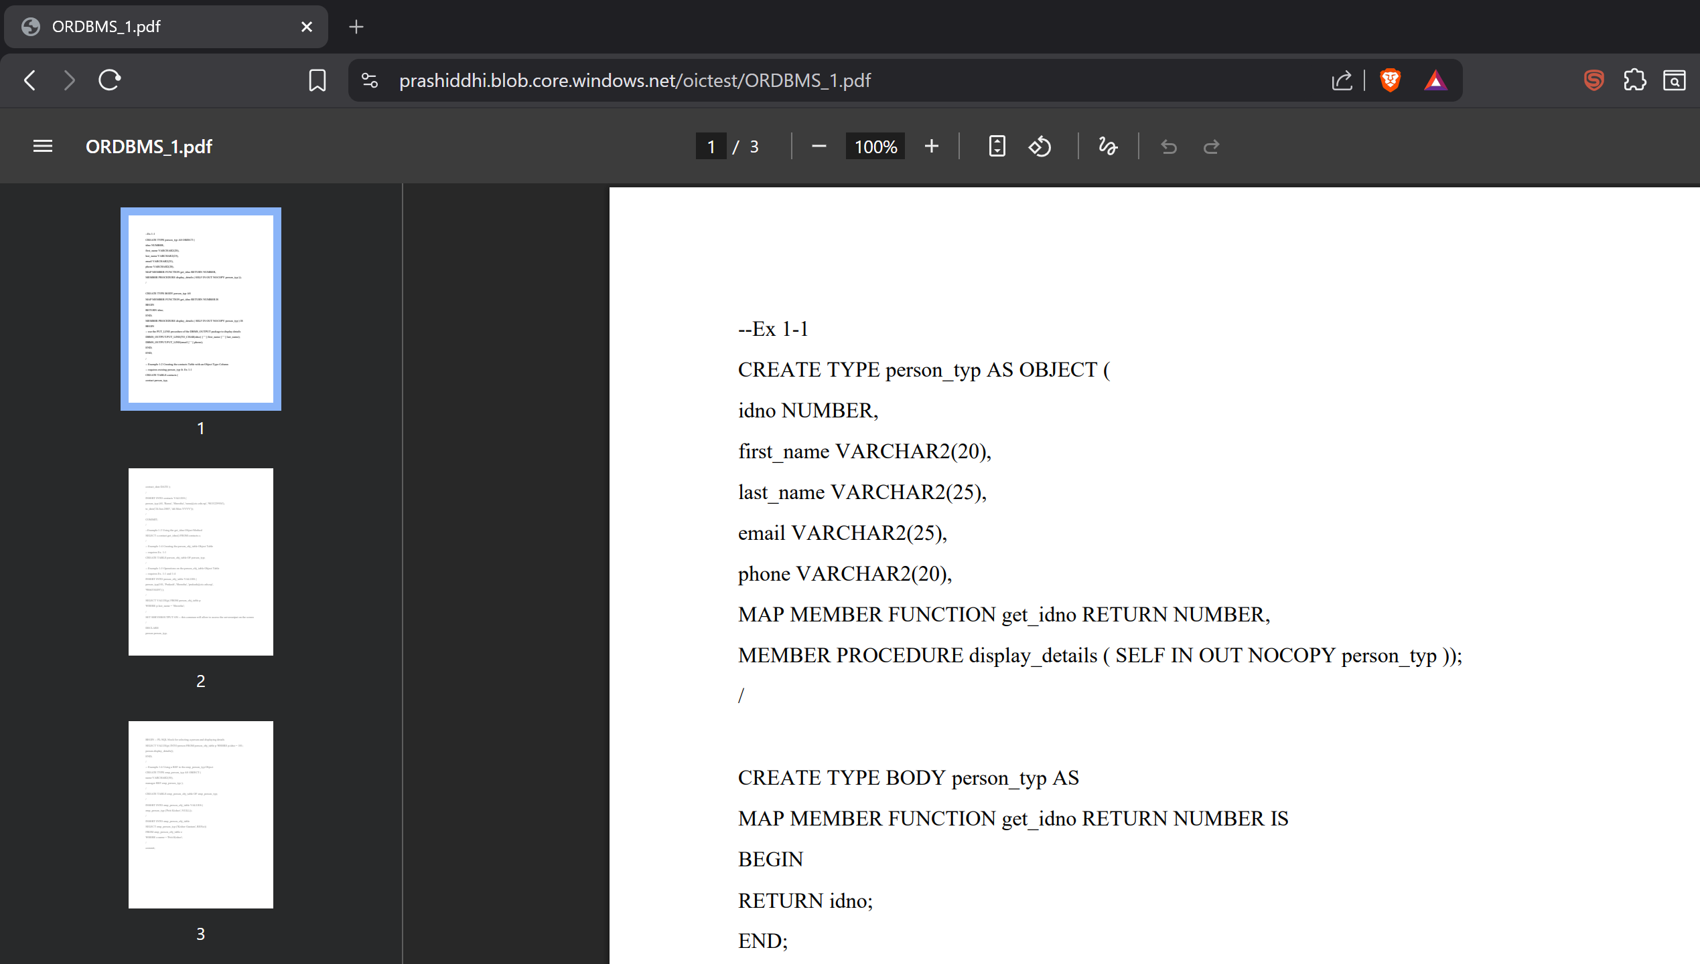

Result and Conclusion
Result: A blob container was successfully created and a PDF file was uploaded and accessed using its blob URL, demonstrating Azure Blob Storage’s ability to store and serve unstructured data. Additionally, static website hosting was enabled using the $web container, and HTML files were uploaded and accessed through the primary endpoint. The experiment verified both blob file access and static website hosting functionality.
Conclusion: This experiment demonstrated the core concepts of Azure Blob Storage, including container creation, blob upload, public access via URLs, and static website hosting. By uploading and accessing a PDF file, the ability of Blob Storage to serve files over the internet was confirmed. Hosting a static website further showed how Blob Storage can be used as a cost-effective and scalable solution for both file storage and web hosting purposes.

